Object-Oriented Programming in Java: Lab Report
Name: Dadiso Mondiwa
Reg number: H250655C
GitHub repository: https://github.com/Dadiso-dev/java-oop-labs

Lab 1: Classes and Objects
Objectives: Define a class with fields and methods; create objects with new and use the dot operator; explain that a variable holds a reference, and what aliasing and null mean.
GitHub folder: lab01-classes-and-objects
Screenshots needed
- [SCREENSHOT 1.1] Programs 1.1 to 1.3: terminal after java Student, java ReferenceDemo and java Course.

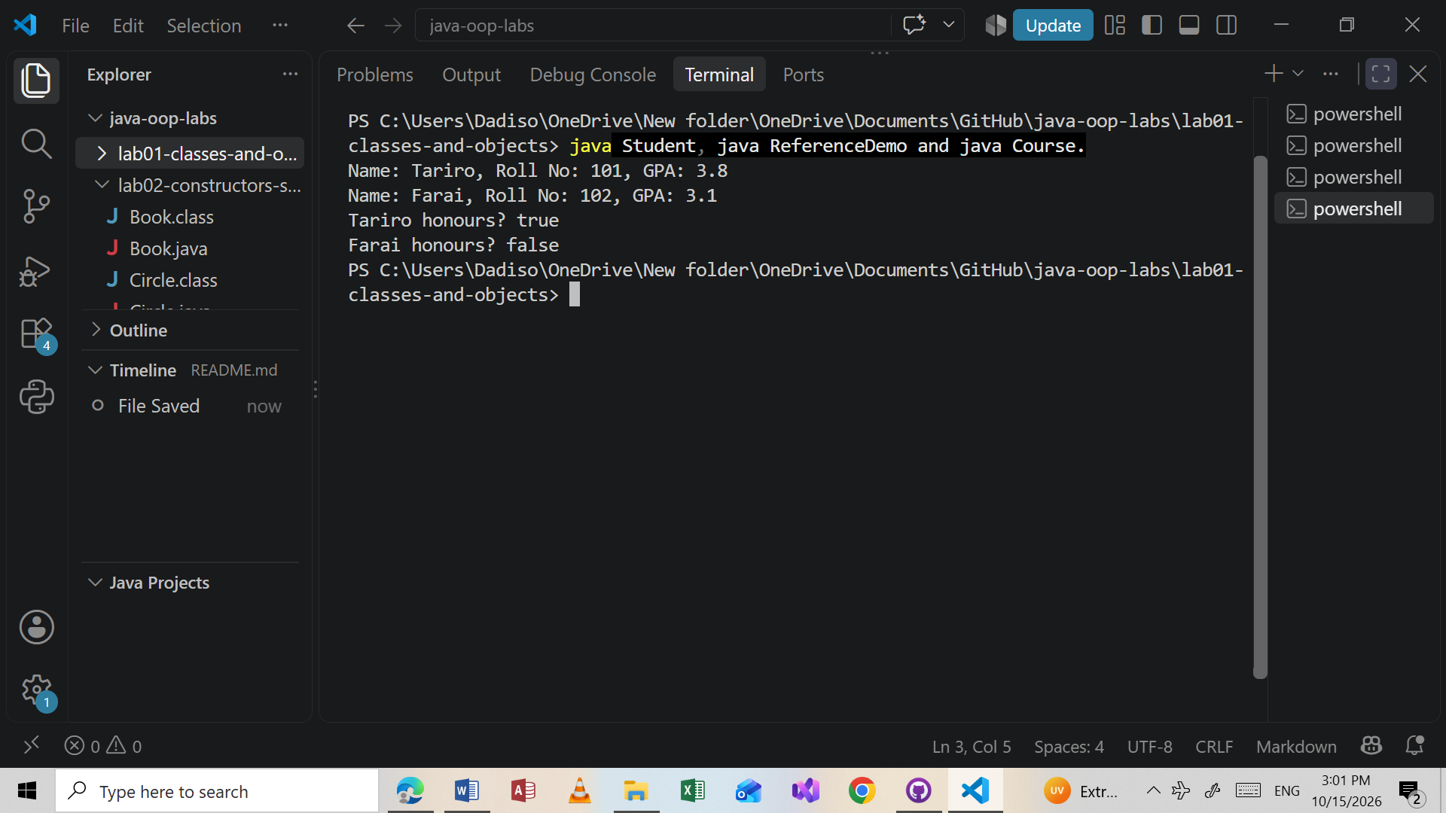

- [SCREENSHOT 1.2] Exercises 1 and 2: java Car (three cars and the antique lines).

public class Car{
String brand;
int year;
int mileage ;

void display(){
System.out.println("Brand : " + brand + " Year: " + year +" Mileage: " + mileage );

}

boolean isAntique(){
return 2026 - year > 25;
}

public static void main (String[] args){

Car c1 = new Car();
c1.brand = "Toyota";
c1.year = 2018;
c1.mileage = 90000;

Car c2 = new Car();
c2.brand ="Honda";
c2.year = 2000;
c2.mileage =210000;

Car c3 = new Car();
c3.brand = "BMW";
c3.year = 2004;
c3.mileage =15000;

c1. display();
c2. display();
c3 .display();

System.out.println(c1.brand + " antique " + c1.isAntique());
System.out.println (c2.brand + " antique " + c2.isAntique());
System.out.println(c3.brand + " antique " + c3.isAntique());
}

}

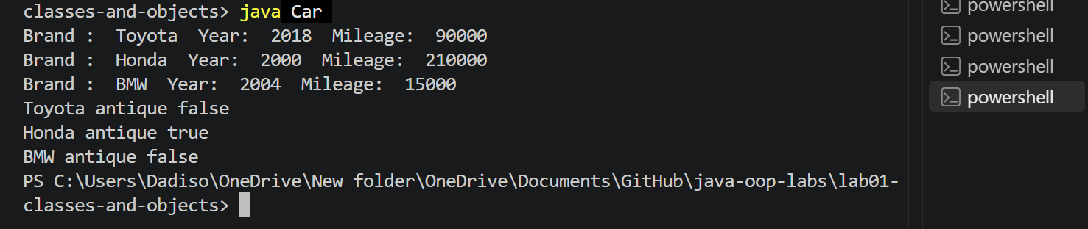

- [SCREENSHOT 1.3] Exercise 3: java Rectangle.
- public class Rectangle {
- double width;
- double height;

- double area() {
- return width * height;
- }

- double perimeter() {
- return 2 * (width + height);
- }

- public static void main(String[] args) {
- // Step 1: make the array (5 empty slots)
- Rectangle[] rects = new Rectangle[5];

- // Step 2: fill it with 5 different rectangles
- for (int i = 0; i < rects.length; i++) {
- rects[i] = new Rectangle();
- rects[i].width = i + 2;
- rects[i].height = i + 3;
- }

- // Step 3: find the rectangle with the largest area
- Rectangle largest = rects[0];
- for (int i = 1; i < rects.length; i++) {
- if (rects[i].area() > largest.area()) {
- largest = rects[i];
- }
- }

- // Step 4: print the result
- System.out.println("Largest: " + largest.width + " x " + largest.height);
- System.out.println("Area: " + largest.area());
- System.out.println("Perimeter: " + largest.perimeter());
- }
- }

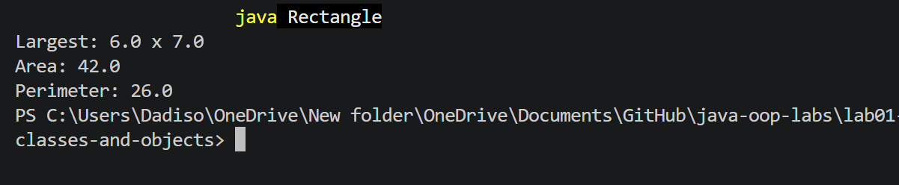

- [SCREENSHOT 1.4] Exercise 4: java AliasTest

public class AliasTest {
public static void main(String[] args) {
Rectangle r1 = new Rectangle();
r1.width = 5;
r1.height = 3;

Rectangle r2 = r1;
r2.width = 10;

System.out.println("r1.width = " + r1.width);
System.out.println("r2.width = " + r2.width);
}
}

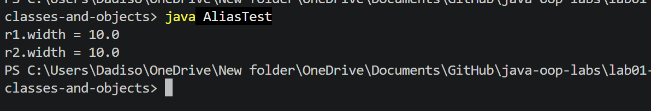

- [SCREENSHOT 1.5] Exercise 5: java Person (prints the city).

public class Person {
String name;
Address address;

public static void main(String[] args) {
Address a = new Address();
a.city = "Harare";

Person p = new Person();
p.name = "Dadiso";
p.address = a;

System.out.println(p.name + " lives in " + p.address.city);
}
}

- [SCREENSHOT 1.6] Exercise 5: java NullDemo showing the NullPointerException error.

public class NullDemo {
public static void main(String[] args) {
Person p = new Person();
p.name = "Dadiso";
p.address = null;
System.out.println(p.address.city);
}
}

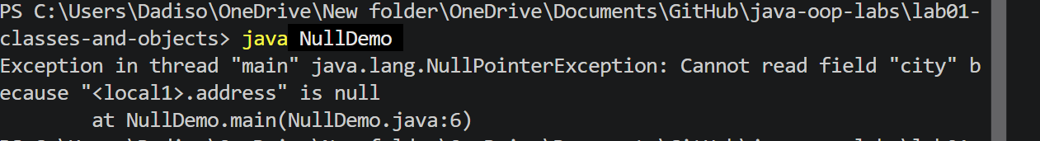

Exercise 4 explanation: My prediction was 5.0 . The program printed r1.width = 10.0 and r2.width = 10.0. This is because Rectangle r2 = r1; copies the reference (the address), not the rectangle itself. So r1 and r2 are two names for the same object, and changing r2.width changes the one rectangle that r1 also points to. To get an independent copy I would have to create a new Rectangle with new and copy the values across.
Conclusion: A class is a blueprint that describes the fields and methods of something, and an object is one real thing made from it with new. A variable of a class type holds a reference, so copying it creates an alias, and using a null reference causes a NullPointerException. Exercises 4 and 5 showed both ideas clearly.

Lab 2: Constructors, this and static
Objectives: Write constructors, overload them and chain them with this(...); use this and static members; explain initialisation order with static and instance blocks.
GitHub folder: lab02-constructors-static
Screenshots needed
- [SCREENSHOT 2.1] Program 2.1: java Book.
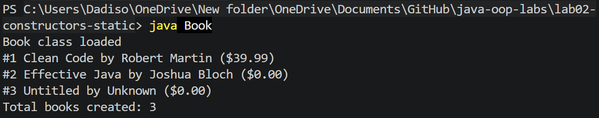

- [SCREENSHOT 2.2] Program 2.2: java InitOrder.
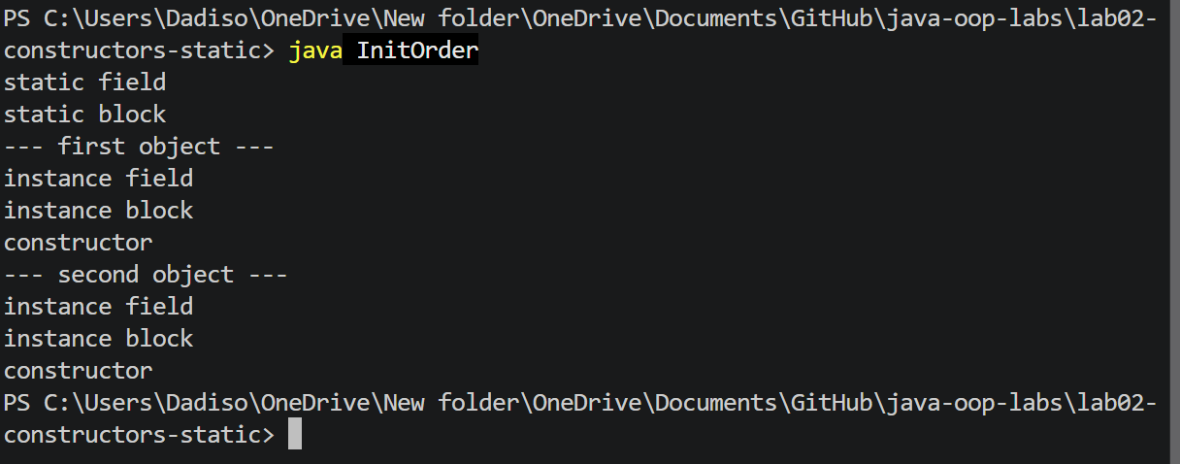

- [SCREENSHOT 2.3] Program 2.3: java Point.

- [SCREENSHOT 2.4] Exercises 1 and 2: java Circle (including the circles created count).

public class Circle {

private static int count = 0;

private double radius;

public Circle(double radius) {
this.radius = radius;
count++;
}

public Circle() {
this(1.0);

}
public static int getCount() {
return count;
}

public void display() {
System.out.println("Radius: " + radius);
}

public static void main(String[] args) {
Circle c1 = new Circle(5.0);
Circle c2 = new Circle();
c1.display();
c2.display();
System.out.println("Circles created: " + Circle.getCount());
}
}

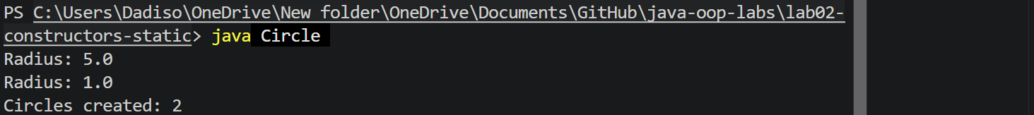

- [SCREENSHOT 2.5] Exercise 3: java Employee.

public class Employee {

private static int nextId = 1;
private final int employeeId;
private String name;
private double salary;

public Employee(String name, double salary) {
this.employeeId = nextId++;
this.name = name;
this.salary = salary;
}

public Employee(String name) {
this(name, 0.0);
}

public Employee() {
this("Unknown");
}

public Employee(Employee other) {
this(other.name, other.salary);
}

public static int getCount() {
return nextId - 1;
}

public void display() {
System.out.printf("ID %d: %s, $%.2f%n", employeeId, name, salary);
}

public static void main(String[] args) {
Employee e1 = new Employee("Tariro", 1500.0);
Employee e2 = new Employee("Farai");
Employee e3 = new Employee();
Employee e4 = new Employee(e1);

e1.display();
e2.display();
e3.display();
e4.display();
System.out.println("Employees created: " + Employee.getCount());
}
}

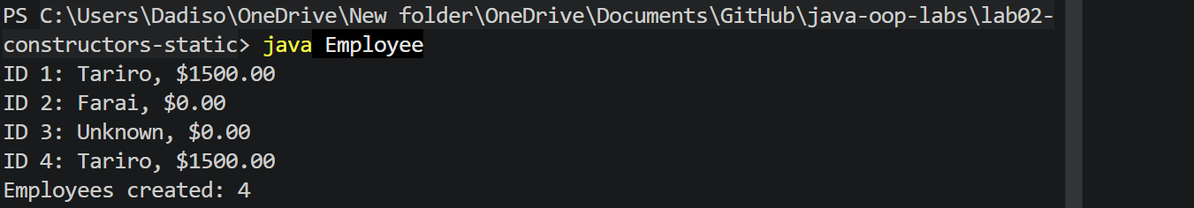

- [SCREENSHOT 2.6] Exercise 4: java InitBlocks.

public class InitBlocks {
static { System.out.println("static 1"); }
{ System.out.println("instance 1"); }
static { System.out.println("static 2"); }
{ System.out.println("instance 2"); }

InitBlocks() { System.out.println("constructor"); }

public static void main(String[] args) {
System.out.println("main start");
new InitBlocks();
new InitBlocks();
}
}

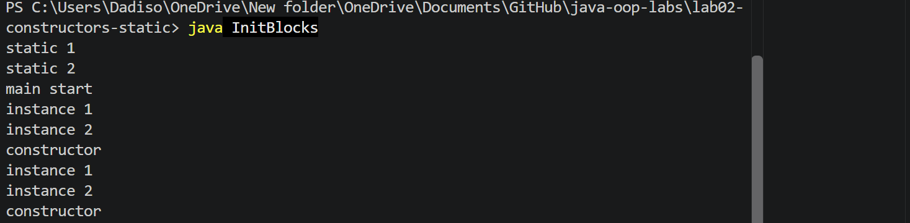

Exercise 4: The real output was: static 1, static 2, main start, then instance 1, instance 2, constructor for each of the two objects. The rule is that static blocks run once, when the class is loaded and before main starts, in the order they are written. Instance blocks run before the constructor body every time an object is created, so they ran twice.
Conclusion: A constructor has the same name as the class and no return type, and it sets up an object when it is created. Overloaded constructors can call each other with this(...), which avoids repeating code. A static member belongs to the class and is shared by all objects, which is why the counters in Circle and Employee keep a running total.

Lab 3: Encapsulation
Objectives: Protect data with private fields, getters, setters and validation; avoid leaking internal collections by returning safe copies; design an immutable class.
GitHub folder: lab03-encapsulation
- [SCREENSHOT 3.1] Programs 3.1 and 3.2: java BankDemo and java Team
- .
- import java.util.ArrayList;
- import java.util.Collections;
- import java.util.List;

- public class BankAccount {
- private final String accountNumber;
- private String ownerName;
- private double balance;
- private final List<String> history = new ArrayList<>();

- public BankAccount(String accountNumber, String ownerName, double openingBalance) {
- if (openingBalance < 0) {
- throw new IllegalArgumentException("Opening balance cannot be negative");
- }
- this.accountNumber = accountNumber;
- setOwnerName(ownerName);
- this.balance = openingBalance;
- history.add(String.format("Opened with %.2f", openingBalance));
- }

- public String getAccountNumber() { return accountNumber; }
- public String getOwnerName() { return ownerName; }
- public double getBalance() { return balance; }

- public void setOwnerName(String ownerName) {
- if (ownerName == null || ownerName.isBlank()) {
- throw new IllegalArgumentException("Owner name required");
- }
- this.ownerName = ownerName.trim();
- }

- public void deposit(double amount) {
- if (amount <= 0) {
- throw new IllegalArgumentException("Deposit must be positive");
- }
- balance += amount;
- history.add(String.format("Deposit: %.2f", amount));
- }

- public boolean withdraw(double amount) {
- if (amount <= 0) {
- throw new IllegalArgumentException("Withdrawal must be positive");
- }
- if (amount > balance) {
- return false;
- }
- balance -= amount;
- history.add(String.format("Withdraw: %.2f", amount));
- return true;
- }

- public List<String> getHistory() {
- return Collections.unmodifiableList(new ArrayList<>(history));
- }

- @Override
- public String toString() {
- return String.format("%s [%s] balance: %.2f", accountNumber, ownerName, balance);
- }
- }

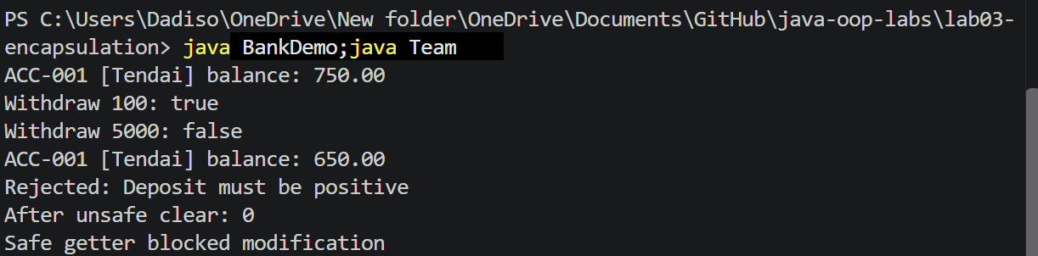

- [SCREENSHOT 3.2] Exercises 1 and 2: java Student (grade and the rejected marks message).

public class Student {
private String name;
private int marks;

public Student(String name, int marks) {
this.name = name;
setMarks(marks);
}

public String getName() { return name; }
public int getMarks() { return marks; }

public void setMarks(int marks) {
if (marks < 0 || marks > 100) {
throw new IllegalArgumentException("Marks must be between 0 and 100");
}
this.marks = marks;
}

public String getGrade() {
if (marks >= 70) return "A";
if (marks >= 60) return "B";
if (marks >= 50) return "C";
return "F";
}

public static void main(String[] args) {
Student s = new Student("Rudo", 78);
System.out.println(s.getName() + ": " + s.getMarks() + " -> " + s.getGrade());

s.setMarks(45);
System.out.println(s.getName() + ": " + s.getMarks() + " -> " + s.getGrade());

try {
s.setMarks(120);
} catch (IllegalArgumentException e) {
System.out.println("Rejected: " + e.getMessage());
}
}
}

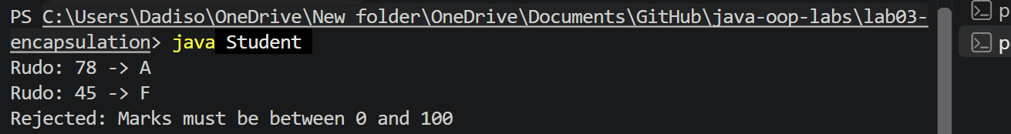

- [SCREENSHOT 3.3] Exercise 3: java HistoryDemo.
- public class HistoryDemo {
- public static void main(String[] args) {
- BankAccount acc = new BankAccount("ACC-002", "Chipo", 100.00);
- acc.deposit(50.00);
- acc.withdraw(30.00);
- acc.withdraw(1000.00);

- for (String line : acc.getHistory()) {
- System.out.println(line);
- }

- try {
- acc.getHistory().add("hack");
- } catch (UnsupportedOperationException e) {
- System.out.println("History is read-only");
- }
- }
- }

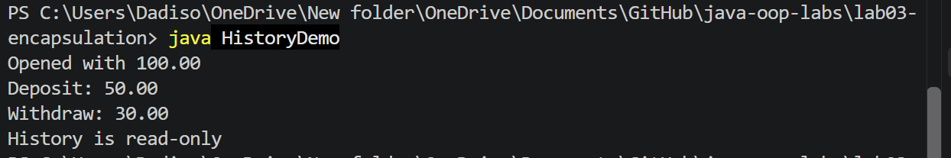

- [SCREENSHOT 3.4] Exercise 4: java ImmutablePerson.
- public final class ImmutablePerson {
- private final String name;
- private final int age;

- public ImmutablePerson(String name, int age) {
- if (name == null || name.isBlank()) {
- throw new IllegalArgumentException("Name required");
- }
- if (age < 0) {
- throw new IllegalArgumentException("Age cannot be negative");
- }
- this.name = name;
- this.age = age;
- }

- public String getName() { return name; }
- public int getAge() { return age; }

- public ImmutablePerson withAge(int newAge) {
- return new ImmutablePerson(name, newAge);
- }

- @Override
- public String toString() {
- return name + " (" + age + ")";
- }

- public static void main(String[] args) {
- ImmutablePerson p1 = new ImmutablePerson("Tendai", 20);
- ImmutablePerson p2 = p1.withAge(21);
- System.out.println(p1);
- System.out.println(p2);
- }
- }

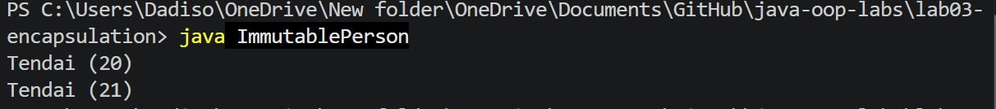

Exercise 4 design choices: The class is final, so no subclass can add a way to change the data. The fields are private final, so they can be set once in the constructor and never reassigned. There are no setters, so nothing outside can change the object. The constructor validates the name and age, so an invalid person can never exist. withAge returns a new ImmutablePerson instead of changing the old one, so p1 stays at 20 while p2 is 21.
Conclusion: Fields are private so that other code cannot put an object into an invalid state. BankAccount has no setBalance method because the balance should only change through deposit and withdraw, which check the amount first. Returning a read-only copy of a list (as getHistory and getMembers do) stops outside code from emptying or changing the internal data.

Lab 4: Inheritance
Objectives: Reuse code with extends, super and @Override; explain constructor order in a hierarchy; choose between inheritance (is-a) and composition (has-a).
GitHub folder: lab04-inheritance

- [SCREENSHOT 4.1] Program 4.1: java CompanyDemo.
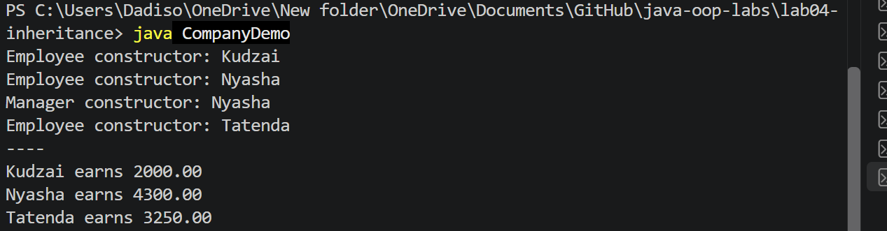

- [SCREENSHOT 4.2] Programs 4.2 and 4.3: java Chain and java CompositionDemo.

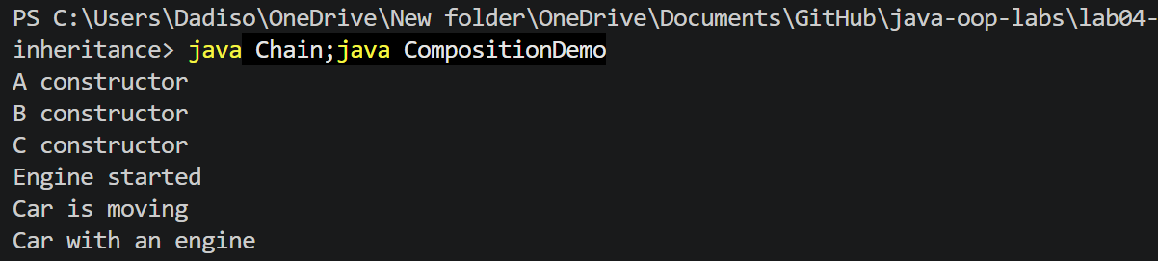

- [SCREENSHOT 4.3] Exercises 1 and 2: java PeopleDemo.
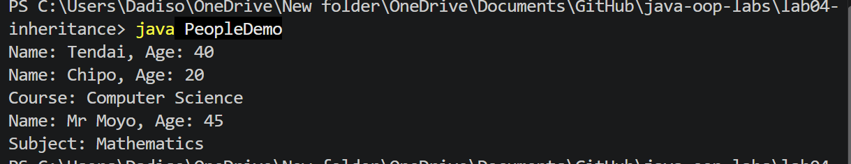

- [SCREENSHOT 4.4] Exercise 3: java VehicleDemo (run inside the vehicles folder).
- class Vehicle {
- Vehicle() { System.out.println("Vehicle constructor"); }
- }
- class Car extends Vehicle {
- Car() { System.out.println("Car constructor"); }
- }
- class ElectricCar extends Car {
- ElectricCar() { System.out.println("ElectricCar constructor"); }
- }
- public class VehicleDemo {
- public static void main(String[] args) {
- new ElectricCar();
- }
- }

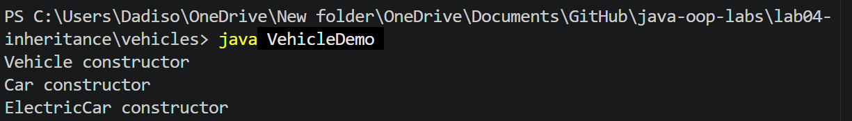

- [SCREENSHOT 4.5] Exercise 4: the compile ERROR from the broken Dog. In DogDemo.java
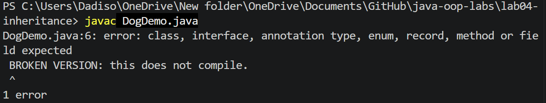

- [SCREENSHOT 4.6] Exercise 4: java DogDemo after fixing (prints Dog created: Rex).

class Animal {
protected String name;
Animal(String name) { this.name = name; }
}

/* BROKEN VERSION: this does not compile.
class BrokenDog extends Animal {
BrokenDog() { }
}
*/

class Dog extends Animal {
Dog(String name) { super(name); }
}

public class DogDemo {
public static void main(String[] args) {
Dog d = new Dog("Rex");
System.out.println("Dog created: " + d.name);
}
}

Exercise 3: The output was Vehicle constructor, then Car constructor, then ElectricCar constructor. The first line of every subclass constructor is an implicit call to super(), so the parent constructor runs first. The object is built from the top of the hierarchy down to the class that was created with new.
Exercise 4: Animal only has the constructor Animal(String name). Once a class defines any constructor, Java no longer gives it a hidden no-argument one. A subclass constructor always starts with an implicit super(), so Dog() { } looks for Animal(), which does not exist, and the compiler reports an error. The fix is to call super(name) explicitly as the first line of the Dog constructor.
Conclusion: Inheritance means is-a: a Manager is an Employee, so it reuses the Employee fields and methods and changes only what differs. Composition means has-a: a Car has an Engine and uses it, but is not an Engine. I use inheritance when the is-a relationship is true and composition when one object simply uses another.

Lab 5: Polymorphism
Objectives: Tell overloading (decided at compile time) from overriding (decided at run time); use dynamic dispatch through a superclass reference; use instanceof and casting safely.
GitHub folder: lab05-polymorphism

- [SCREENSHOT 5.1] Programs 5.1 to 5.3: java Calculator, java Shapes and java CastingDemo.
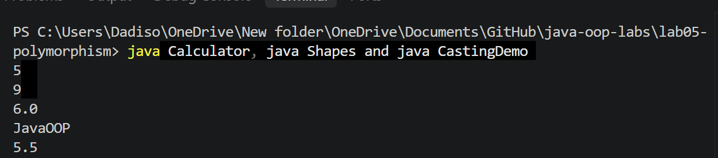

- [SCREENSHOT 5.3] Exercise 2: java AnimalDemo (run inside the animals folder).

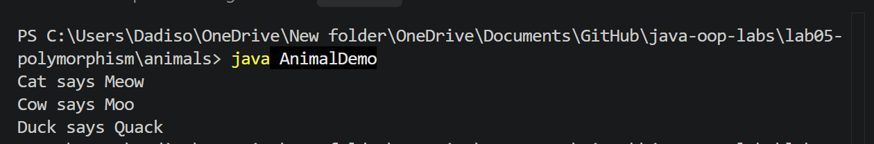

- [SCREENSHOT 5.4] Exercise 3: java PayrollDemo.
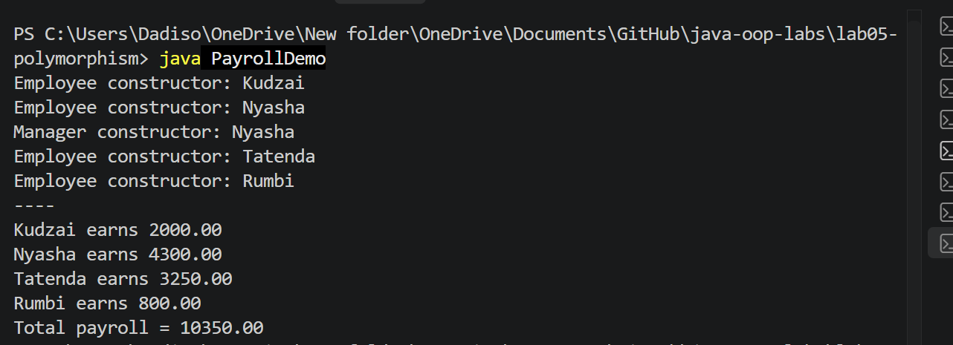

- [SCREENSHOT 5.5] Exercise 4: java FieldVsMethod.
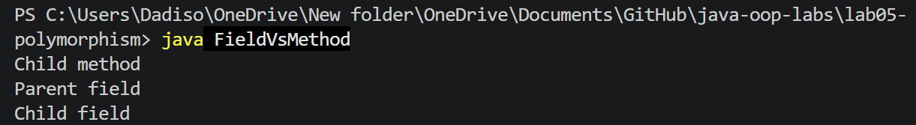

Exercise 3: The payroll loop works on Employee references and calls calculatePay(). At run time Java runs the version that belongs to the real object (dynamic dispatch), so Manager, Developer and Intern each use their own calculation. Intern only had to override calculatePay(), and the loop did not need any change.
Exercise 4: p.who() printed Child method because methods are chosen by the real object, which is a Child even though the variable is declared as Parent. p.label printed Parent field because fields (and static methods) are chosen by the declared type of the variable. After the cast Child c = (Child) p; the declared type is Child, so c.label gave Child field.
Conclusion: Overloading is the same method name with different parameters in one class (like the four print methods), and the compiler chooses which one to call. Overriding is a subclass replacing an inherited method with the same signature (like area() in each shape), and the JVM chooses at run time from the real object. Overriding is what makes polymorphism work.

Lab 6: Abstraction and Interfaces
Objectives: Use abstract classes and interfaces (including default and static methods); explain when to choose each; sort objects with Comparable and Comparator.
GitHub folder: lab06-abstraction

- [SCREENSHOT 6.1] Programs 6.1 to 6.3: java VehicleDemo, java InterfaceDemo and java ComparableDemo.

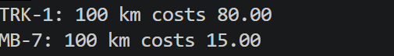

- [SCREENSHOT 6.2] Exercise 1: java ShapeDemo.

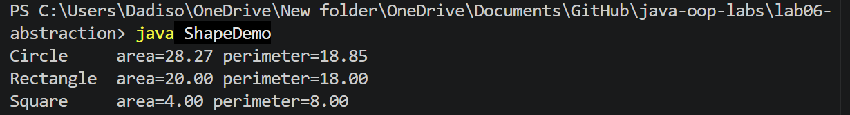
- [SCREENSHOT 6.3] Exercise 2: java FlyDemo.

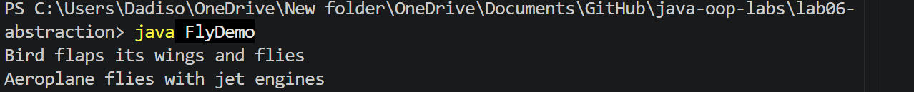

- [SCREENSHOT 6.4] Exercise 3: java AccountDemo.

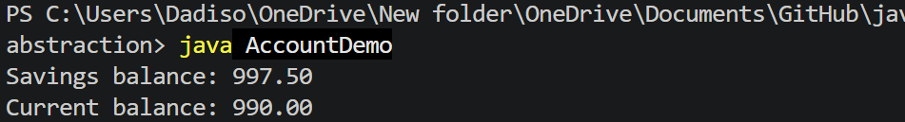

- [SCREENSHOT 6.5] Exercise 4: java StudentSort.

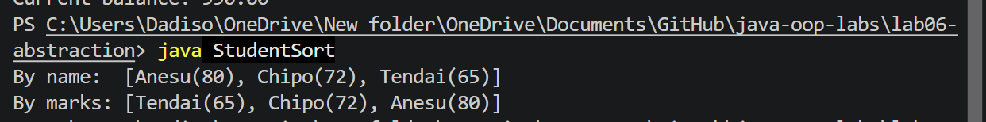

Conclusion: I use an abstract class when closely related classes share fields and code but each must supply its own part, like Account with a shared balance and a different monthlyFee() for Savings and Current. I use an interface for a capability that unrelated classes can share, like Flyable for Bird and Aeroplane. A class can implement many interfaces but extend only one class. Comparable gives a class one natural order through compareTo, so Arrays.sort knows how to sort it, and a Comparator supplies other orders.

Lab 7: Exception Handling
Objectives: Handle errors with try, catch and finally; create custom checked exceptions; use try-with-resources and exception chaining.
GitHub folder: lab07-exception-handling

- [SCREENSHOT 7.1] Programs 7.1 to 7.3: java ExceptionBasics, java Wallet and java ResourceDemo.
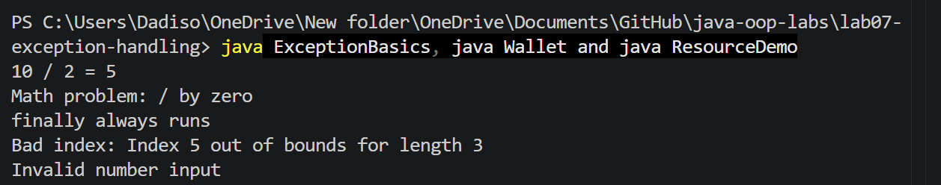

- [SCREENSHOT 7.2] Exercise 1: java DivideInput run three times (10 and 2; 10 and 0; abc).
- import java.util.Scanner;

- public class DivideInput {
- public static void main(String[] args) {
- Scanner in = new Scanner(System.in);
- try {
- System.out.print("Enter first integer: ");
- int a = Integer.parseInt(in.nextLine().trim());
- System.out.print("Enter second integer: ");
- int b = Integer.parseInt(in.nextLine().trim());
- System.out.println(a + " / " + b + " = " + (a / b));
- } catch (NumberFormatException e) {
- System.out.println("Please enter whole numbers only.");
- } catch (ArithmeticException e) {
- System.out.println("Cannot divide by zero.");
- } finally {
- in.close();
- }
- }
- }

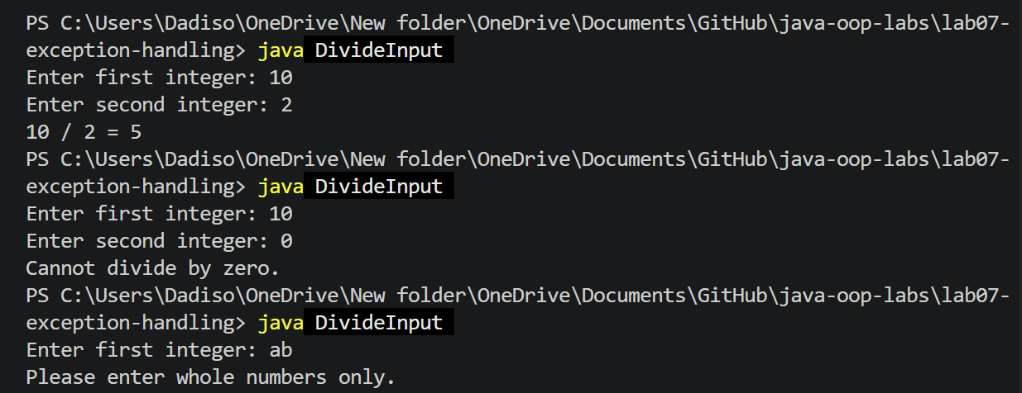

- [SCREENSHOT 7.3] Exercise 2: java ArrayAccess.
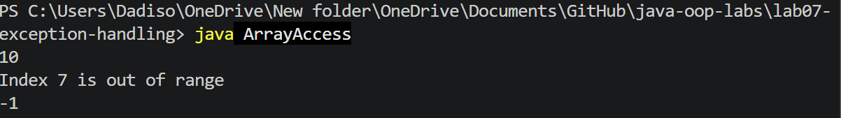

- [SCREENSHOT 7.4] Exercise 3: java AgeValidator.
- public class AgeValidator {

- static void validateAge(int age) throws InvalidAgeException {
- if (age < 0 || age > 120) {
- throw new InvalidAgeException("Age " + age + " is outside 0 to 120");
- }
- }

- public static void main(String[] args) {
- int[] ages = {25, -3, 150};
- for (int a : ages) {
- try {
- validateAge(a);
- System.out.println("Age " + a + " is valid");
- } catch (InvalidAgeException e) {
- System.out.println("Rejected: " + e.getMessage());
- }
- }
- }
- }

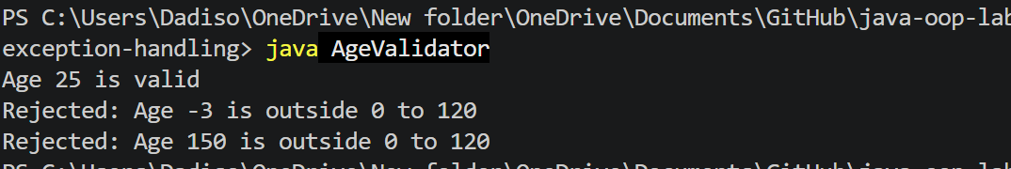

- [SCREENSHOT 7.5] Exercise 4: java BankTest.
- public class BankTest {
- public static void main(String[] args) {
- BankAccount acc = new BankAccount("ACC-001", 500);
- try {
- acc.withdraw(100);
- System.out.println("Balance: " + acc.getBalance());
- acc.withdraw(1000);
- } catch (InsufficientFundsException e) {
- System.out.println(e.getMessage());
- System.out.println("Short by: " + e.getShortfall());
- }
- }
- }

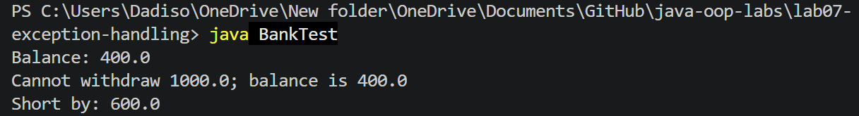

Exercise 4 discussion: Returning false is simple and needs no try/catch, but the caller can ignore it without noticing, and it says nothing about why the withdrawal failed. Throwing InsufficientFundsException forces the caller to handle the problem, carries a clear message and the shortfall amount, and keeps error handling separate from the normal flow. The disadvantages are more code, and callers must write try/catch even for a situation that may be common.
Conclusion: A checked exception extends Exception, and the compiler forces me to catch it or declare it (InsufficientFundsException, InvalidAgeException). An unchecked exception extends RuntimeException, usually shows a bug, and catching it is optional (ArithmeticException, IllegalArgumentException). throw creates and throws one exception object right now, while throws in a method signature warns callers which checked exceptions the method may throw.

Lab 8: Generics and Collections
Objectives: Write generic classes and methods; choose the right collection (List, Set, Map, Queue); sort with Comparable and Comparator.
GitHub folder: lab08-generics-collections

- [SCREENSHOT 8.1] Programs 8.1 to 8.3: java GenericsDemo, java CollectionsDemo and java SortingDemo.
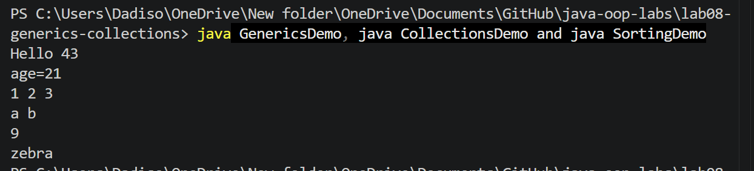

- [SCREENSHOT 8.2] Exercise 1: java ListStats.

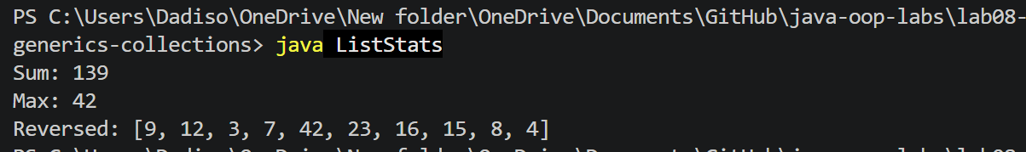

- [SCREENSHOT 8.3] Exercise 2: java RemoveDuplicates.

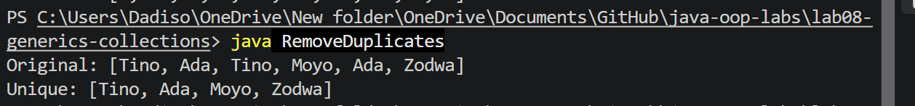

- [SCREENSHOT 8.4] Exercise 3: java StackDemo.

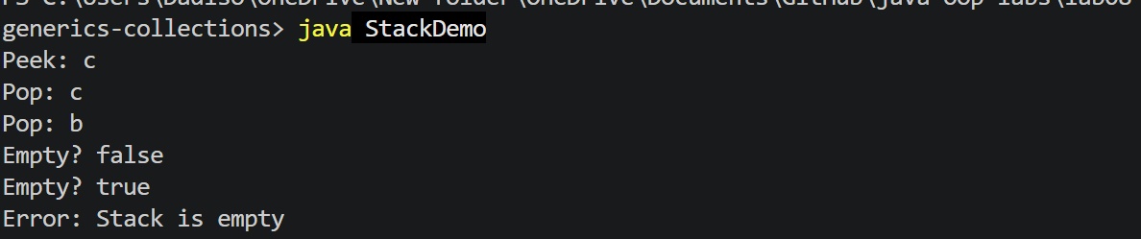

- [SCREENSHOT 8.5] Exercise 4: java WordFrequency.

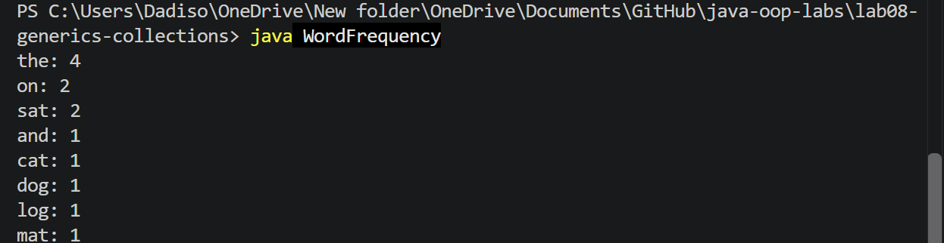

Exercise 2: A Set does not allow duplicates, so copying the list into a set removes them. I used a LinkedHashSet because it also keeps the original insertion order, so the result is Tino, Ada, Moyo, Zodwa. A HashSet would give no guaranteed order, and a TreeSet would sort the names.
Conclusion: Generics let one class or method work with any type while the compiler checks types, so there are no casts and mistakes show up at compile time (Stack of String, Box of Integer). I choose a List for an ordered collection that allows duplicates, a Set for unique items, a Map to look up a value by a key (the word counts), and a Queue or Deque for first-in-first-out or stack behaviour.

Lab 9: Nested Types, Enums and Records
Objectives: Use the four kinds of nested class; define enums and records; override equals, hashCode and toString correctly.
GitHub folder: lab09-nested-enums-records

- [SCREENSHOT 9.1] Programs 9.1 to 9.3: java NestedDemo, java EnumDemo and java ObjectContract.
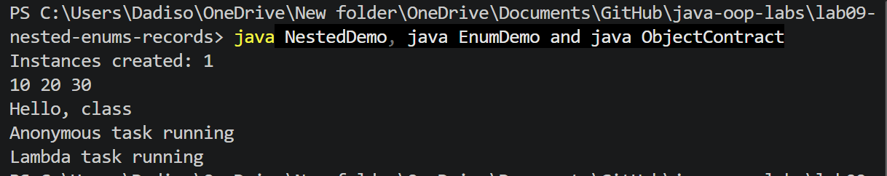

- [SCREENSHOT 9.2] Exercise 1: java LevelDemo.
- 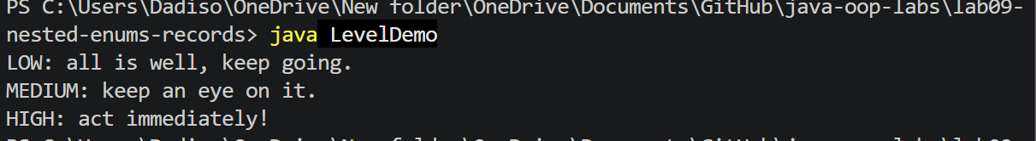

- [SCREENSHOT 9.3] Exercise 2: java StudentRecord.

record Student(String name, int age) {}

public class StudentRecord {
public static void main(String[] args) {
Student s1 = new Student("Chipo", 20);
Student s2 = new Student("Chipo", 20);
Student s3 = new Student("Tendai", 22);

System.out.println(s1);
System.out.println("s1 equals s2: " + s1.equals(s2));
System.out.println("s1 equals s3: " + s1.equals(s3));
System.out.println("s1 == s2: " + (s1 == s2));
System.out.println("Name: " + s1.name());
}
}

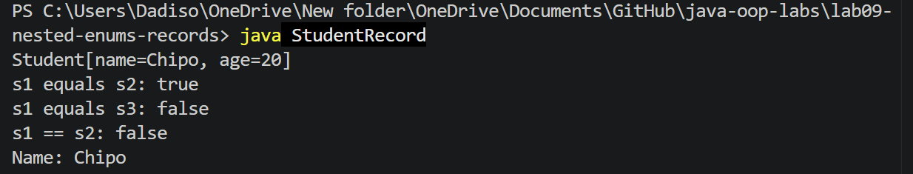

- [SCREENSHOT 9.4] Exercise 3: java BookSet (the duplicate is rejected: true, true, false, Size 2).
- import java.util.HashSet;
- import java.util.Objects;
- import java.util.Set;

- class Book {
- private final String isbn;
- private final String title;

- Book(String isbn, String title) { this.isbn = isbn; this.title = title; }

- @Override
- public boolean equals(Object o) {
- if (this == o) return true;
- if (!(o instanceof Book other)) return false;
- return isbn.equals(other.isbn);
- }

- @Override
- public int hashCode() { return Objects.hash(isbn); }

- @Override
- public String toString() { return title + " [" + isbn + "]"; }
- }

- public class BookSet {
- public static void main(String[] args) {
- Set<Book> shelf = new HashSet<>();
- System.out.println(shelf.add(new Book("111", "Clean Code")));
- System.out.println(shelf.add(new Book("222", "Effective Java")));
- System.out.println(shelf.add(new Book("111", "Clean Code (copy)")));
- System.out.println("Size: " + shelf.size());
- }
- }
t
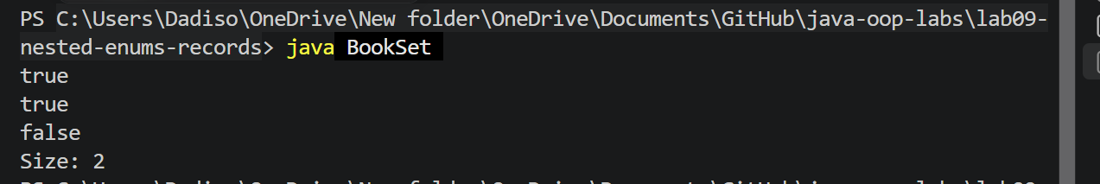

- [SCREENSHOT 9.5] Exercise 4: java LinkedListDemo.

public class LinkedListDemo {
public static void main(String[] args) {
LinkedList<String> list = new LinkedList<>();
list.add("red");
list.add("green");
list.add("blue");

for (String s : list) {
System.out.println(s);
}
System.out.println("Size: " + list.size());
}
}

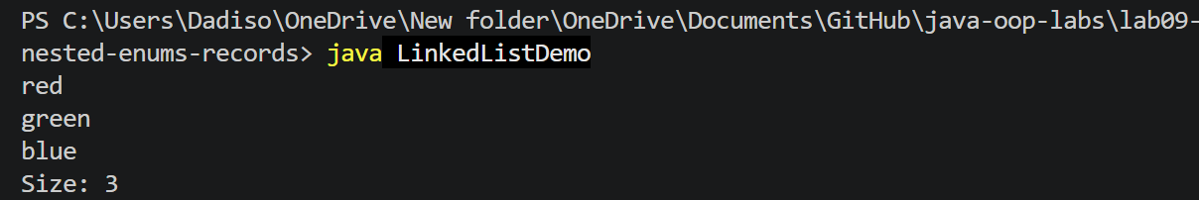

Exercise 3: equals decides when two Book objects count as the same (same ISBN), and a HashSet uses hashCode to find the right bucket before it calls equals. If two equal objects had different hash codes, the set could store both and the duplicate would not be rejected. The contract is that equal objects must always return the same hash code, so the two methods are overridden together using the same field.
Exercise 4: Node is a private static nested class because a node only holds a value and a link, and it does not need to know about any particular list object. The iterator is an inner (non-static) class because it must read the list's own head field to know where to start. The list implements Iterable<T>, which is what lets the for-each loop work on it.
Conclusion: An enum is a type with a fixed set of constants (Level: LOW, MEDIUM, HIGH), which is safer than using strings or numbers and works inside a switch. A record is a short way to write an immutable data class: Java generates the constructor, accessors, equals, hashCode and toString (the Student record printed as Student[name=Chipo, age=20]).

Lab 10: File I/O, Lambdas and Streams
Objectives: Read and write text files with java.nio.file and handle IOException; save and load objects as CSV; use lambdas, method references and the Stream API.
GitHub folder: lab10-files-lambdas-streams
Screenshots needed
- [SCREENSHOT 10.1] Programs 10.1 to 10.3: java FileDemo, java StudentRepository and java StreamDemo.
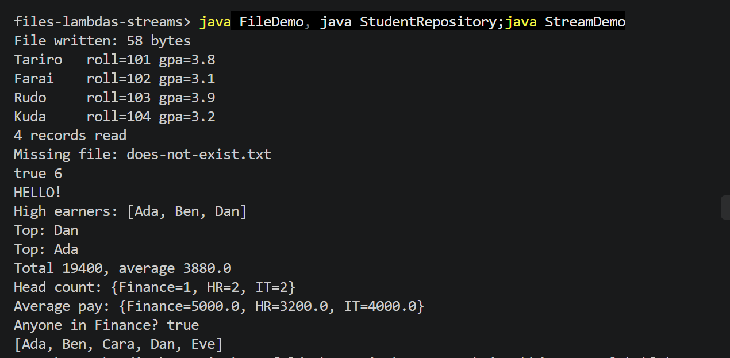

- [SCREENSHOT 10.2] Exercise 1: java SaveLines with the five lines you typed visible.
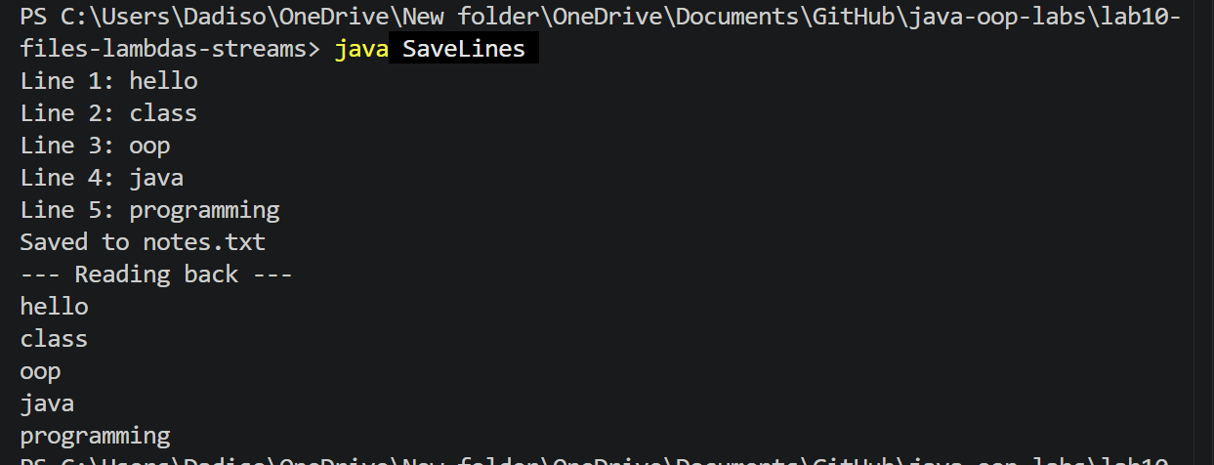

- [SCREENSHOT 10.4] Exercise 2: java RemoveEvens.

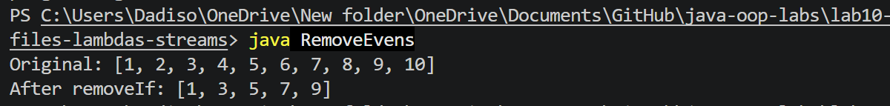

- [SCREENSHOT 10.5] Exercise 3: java TextStats.

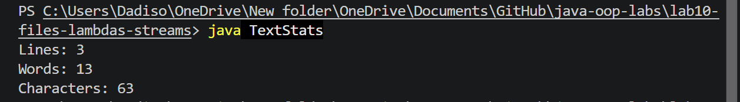

- [SCREENSHOT 10.6] Exercise 4: java AboveAverage.
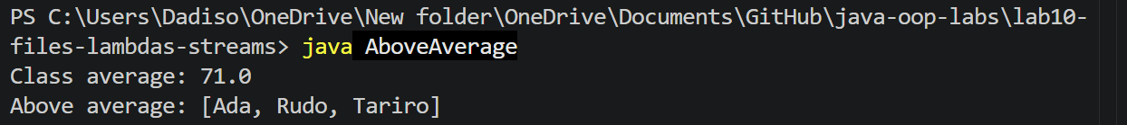

Exercise 2: A Predicate is a functional interface with one method, test, that takes a value and returns true or false. I wrote n -> n % 2 == 0 as a Predicate that is true for even numbers. removeIf calls it on every element of the list and removes the elements for which it returns true, leaving 1, 3, 5, 7, 9.
Conclusion: A stream pipeline has a source (for example list.stream()), intermediate operations such as filter, map and sorted that are lazy, and one terminal operation such as collect or sum that starts the work. A stream does not change its source. IOException is a checked exception because a file may be missing or unreadable, so the compiler forces me to handle it with try/catch or declare it with throws.

Lab 11: Design Patterns and the Library Mini-Project
Objectives: Recognise Singleton, Factory, Strategy and Observer and the problem each solves; combine classes, interfaces, collections, exceptions and file I/O in one working application.
GitHub folder: lab11-design-patterns (the project is in the library-system subfolder)

- [SCREENSHOT 11.1] Programs 11.1 and 11.2: java SingletonFactoryDemo and java StrategyObserverDemo.
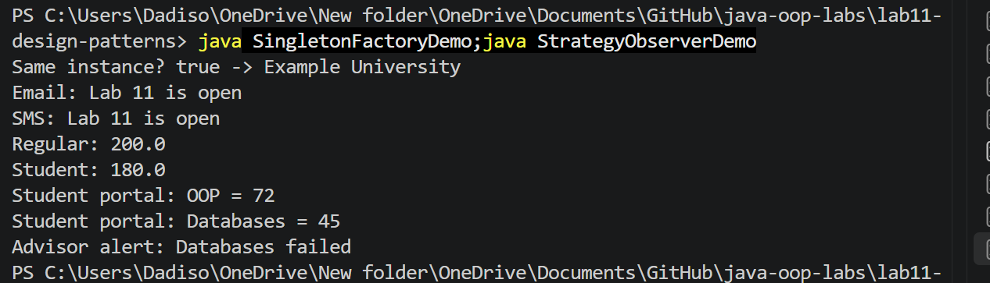

- [SCREENSHOT 11.2] Mini-project: java LibraryDemo (maximise the terminal so the whole output shows).
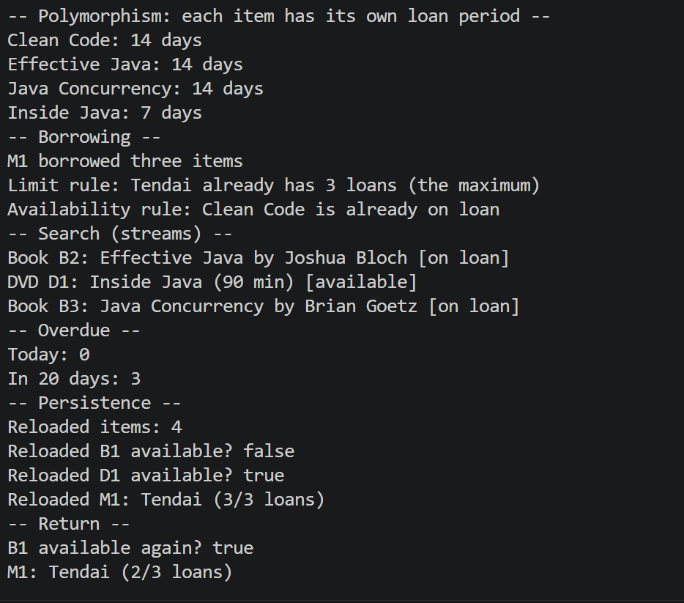

- [SCREENSHOT 11.3] Mini-project: first java LibraryApp session (add a book, register a member, borrow, list overdue with 20, search, then exit with 0).

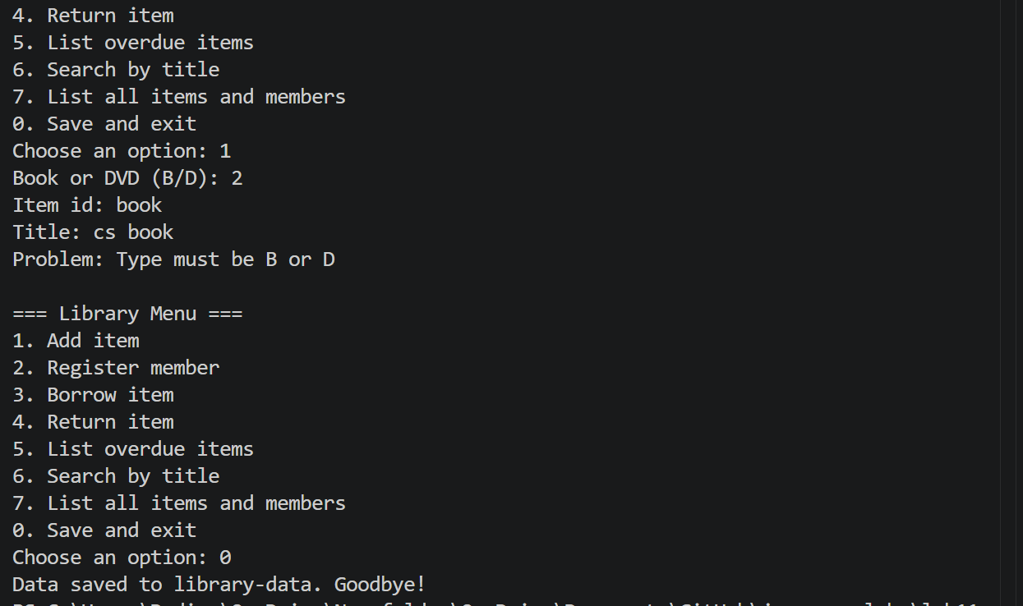

Patterns: Singleton makes sure only one shared instance exists, using a private constructor (AppConfig). Factory creates objects from a name so the caller depends on the Notification interface and not on a specific class (NotificationFactory). Strategy lets an algorithm be swapped at run time (the discount lambda in Checkout). Observer lets many listeners be told when something happens (the grade book notifying the student portal and the advisor).
Mini-project: LibraryItem is an abstract class with Book and Dvd subclasses, and each gives its own loan period and CSV line. The Borrowable interface describes borrow and giveBack. Two custom checked exceptions, ItemNotAvailableException and MemberLimitExceededException, enforce that an item can only be borrowed once and that a member has at most 3 loans. Items and members are stored in maps keyed by id. LibraryStore saves them to items.csv, members.csv and loans.csv on exit and loads them at start. Searching by title and listing overdue loans use stream pipelines.
Conclusion: The most important design point was the order inside borrow: the member limit is checked first and the item is marked as on loan only afterwards, so a failed borrow never leaves an item stuck as unavailable. Saving only the loans, and rebuilding availability from them when loading, means the saved files cannot disagree with each other.
Overall conclusion: Over eleven labs I moved from a single class with fields and methods in Lab 1 to a complete application in Lab 11. Encapsulation kept data valid, inheritance and abstraction reused code, and polymorphism let one loop treat different objects correctly. Exceptions, collections, files and streams made the programs robust and useful.

